**Application Processing Consolidated Meeting Minutes**

Monday, April 19, 2021

8:59 AM

**Attendees:** Seun Mafi, Michael Bavasso, Daniel Benner, Ashish Joshi, Daniel Rodriguez, Jeanne Willis, Padmalatha Ajit

**Date:** April 19, 2021

**Location:** WebEx

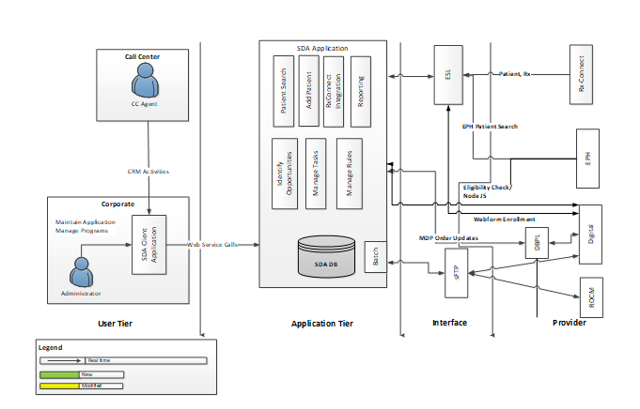

**Michael:** What does this diagram entail?

**Padma:** The call center agent can see the item, see the profile. Whatever action that is, they see in the application. These are the actions they can take using the SDA UI. There is a batch that runs overnight, Either send request to RxConnect, send various data and activities. What jobs and models are there. We can provide all that information. Basically it involves various services to get various information.

**Michael**: Is the data flowing external to CVS health.

**Padma**: No.

**Michael:** So this is all internal?

**Padma:** Yes

**Michael:** We will ask for an updated document. So we can review and understand.

**Bill:** The whole system uses opportunities, rather than question. So it’s a terminology thing.

**Michael:** How many batch jobs do you have?

**Padma:** Some of the jobs are internal and few jobs are digital. So roughly about 60 jobs. There is an internal secure connection from the Enterprise Service Layer (ESL) and RxConnect.

**Michael:** Once we understand the flow, we will want to know what jobs they are. We will ask for a sample set.

**Michael:** What is used to control the batch jobs?

**Padma:** They use **Control M** (Job Scheduler)

**Michael:** Who controls the schedule?

**Padma:** Production control team owns the scheduler, which is an enterprise function for Retail Business, Control M admin. We create the job ID, conditions before and after, We provide all these detail to the team, Then we validate that then it gets pushed into production,

* Control M is the name of the controller tool in PROD Control Admin
* Add, Modifies, deletes in production are the responsibility of Prod Control.

**Michael:** Production support?

**Jeanne**: Control M is part of UCMDB, under Bobby

**Michael:** Is your staff able to execute?

**Padma:** My team has access within testing, but to move into production, it is set up by Production team. Everything is controlled by production Team. Production control Admin

**Michael:** As far as monitoring. If a job fails, who has oversight?

**Padma:** We have production support team. Operation support team that monitors set up, through **MED 3**. If a job turns red, they go check and see if there is an error, They are given the knowledge transfer to do that.

**Michael:** So in the event a job runs at night and everything runs as expected. Do you get update by the next day.

**Padma:** We have 24/7 support team. There are notification and email that says for instance "three processes ran smoothly". The support team is responsible. They monitor it closely.

Monitored by Bob silva.

**Michael:** Is there another means to be notified.

**Padma:** Support team gets notified. We get email. If someone doesn’t respond with 10-15 mins, There is a secondary escalation. And if someone doesn’t not respond, then it gets escalated to me, Padma.

**Michael:** Any event where production support team cannot resolve, is there a backout process?

**Padma:** If they cannot resolve it. There is a discussion with the team. We try to fix the data. We then proceed to take action accordingly.

**Bill:** We just upgraded the software.

**Michael:** Are all of your jobs automated or manual?

**Padma:** It's all automated. Pre-condition, Parallel jobs etc. It's all automated depending on its pre and post conditions.

**Michael:** As far as support job screen. You have any documentation?

**Padma:** We have a batch run book about these jobs and what the jobs is supposed to do at a high level. We have provided to the support team as well, If they can't resolve an issue, then they interact with my team.

**Michael**: Your batch run book. We will like to have that.

**Michael:** Looking at the diagram on screen. Is this an API run? Do you utilize API to operate the SimpleDose application?

**Bill:** What do you mean by API.

**Michael:** It is an application that utilizes end points.

**Bill:** Our application has its own user interface. We also have interfaces out to RxConnect for instance. We use business connected API to access services.

**Michael:** If you are using a API to connect to RxConnect. Then there is a batch process.

**Michael:** So you rely on the batch jobs and also rely on API to get information.

**Bill:** Yes.

* SDA has its own interface. Though this uses APIs when interacting with RxConnect live. But hatch still exists. ESL is the Enterprise Service Layer.

**Michael:** Are there any manual components?

**Bill:** Yes.

* ROCM = Retail Offer Channel Manage
* EPH (Enterprise Patient Hub)